Implement Using Deployment Diagram
K Vamsi
192372062

1. Develop a system using UML for Supermarket Management
System
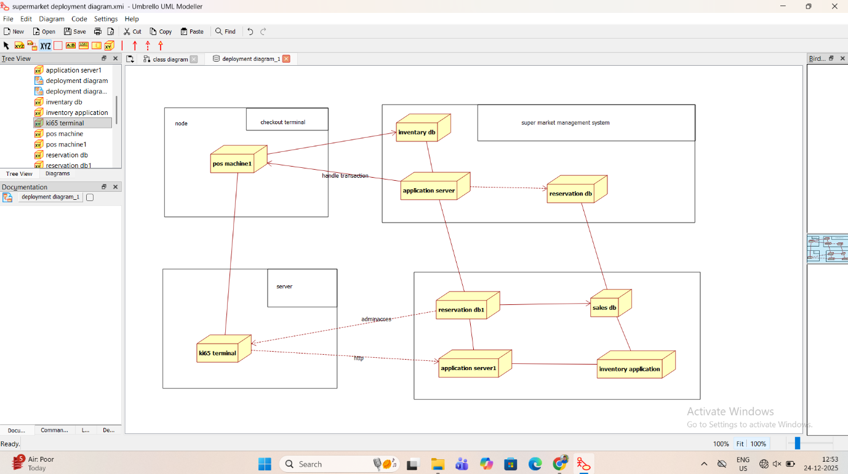
2. Develop a system using UML for the Airline Reservation
System
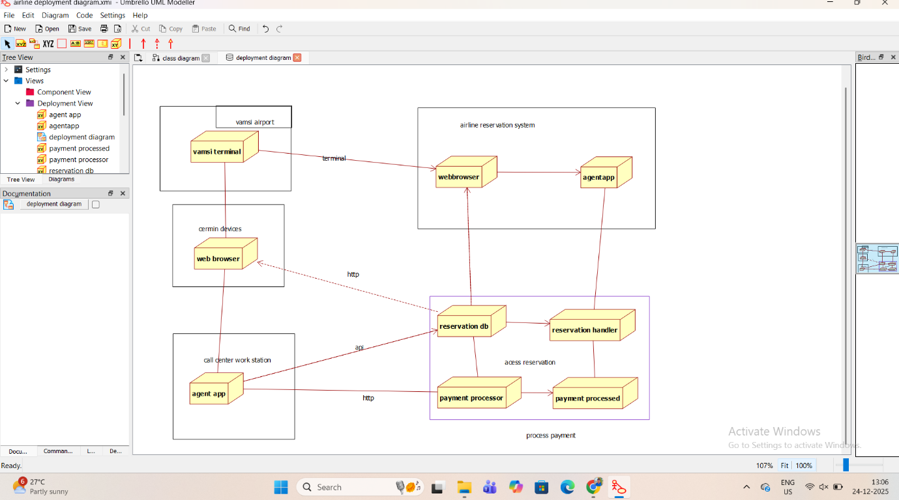
3. Develop a system using UML for the Train Ticket Reservation
System
